Supporting Information
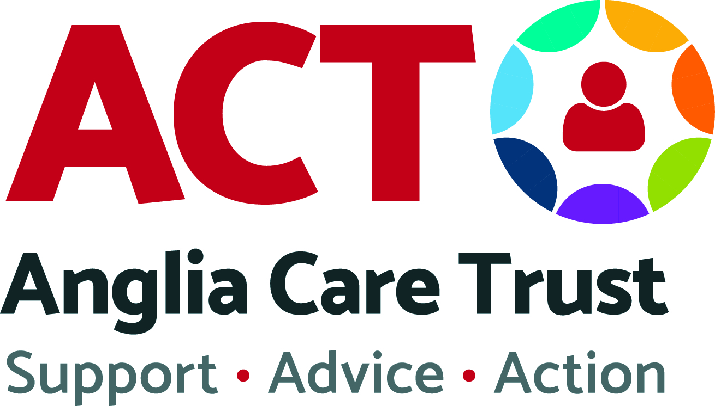
Assistant Supported Housing Officer

ACT has been operating for almost 50 years. We have over 100 paid staff, are supported by over 250 volunteers and we are governed by a supportive Board of Trustees.

We specialise in preventative, community-based services, giving people the stability, support and challenge, which is often required in order to enable them to realise their full potential. We deliver a range of projects promoting the well-being of children, young people, adults and families alike.
Anglia Care Trust has been delivering various Housing related services for over 40 years. Currently, they include Accommodation Based Support for Single Homeless individuals and a private rented Triangle Tenancy Scheme, which leases properties from the Private Rented Sector to provide housing for those unable to get housed by this sector without guarantors.

Due to the growth of these services, we are introducing this new role to work alongside our team of Supported Housing Officers and assist them in their aim to empower Single Homeless people to make positive changes in their lives and achieve independence.

Our Commitment to our Staff

ACT is an employer who believes in work-life balance, reward and recognition and that their personnel are their most valuable resource.

Staff development is important to us and opportunities for personal development will be provided as part of the role.

As a result of this commitment, we currently hold the Investors in People Standard.

Our Commitment to Safeguarding

ACT is committed to safeguarding and promoting the welfare of vulnerable adults and young people and we expect all of our staff and volunteers to share this. We have an experienced team of Designated Safeguarding Officers who offer continued training and support.

All successful applicants will be asked to apply for an Enhanced DBS Disclosure.

Our Commitment to Equality, Diversity and Inclusion

Anglia Care Trust is committed to eliminating discrimination and encouraging diversity amongst our workforce. Our aim is that our workforce will be truly representative of all sections of society and the Service Users we support and each member of personnel feels respected and able to give of their best.
All members of personnel, Service Users and stakeholders will be treated fairly and with respect. Selection for employment, promotion, training or support from our services will be on the basis of suitability. All personnel will be helped and encouraged to develop their full potential and the talents and resources of the workforce will be fully utilized to maximise the efficiency of the organisation.

As a result of this commitment, we currently hold the Investors in Diversity accreditation for charities.

The Recruitment Process

In some instances, we do reserve the right to close a vacancy earlier than the closing date, therefore early applications are encouraged.
As part of our Recruitment Process, we commit to offering an interview to all Veterans seeking employment; service personnel during their resettlement phase; and care leavers. We therefore recommend that you highlight this in your application.

